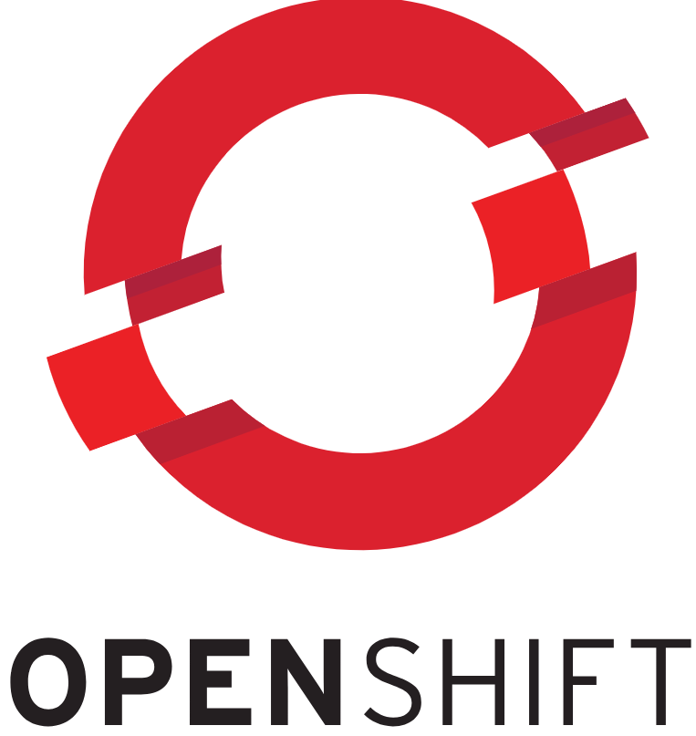
Soniya Chiluveru (Openshift specialist)
Phone: +91 9701028365
Email: soniyachiluveru98@gmail.com

#immediate_joinee #openshift admin #ocp
Career Objective
Experienced OpenShift Engineer with over 3 years in IT, specializing in OpenShift and DevOps. After a year as a Tech Operations Specialist, I want to use my skills in OpenShift, Kubernetes, Docker and other DevOps tools to improve how organizations deploy applications and encourage innovation.

Professional Summary
Over 3+ years of hands-on experience in IT, encompassing Design, Development, Integration of DevOps tools, Build Automation, Configuration Management, Build/Release and Delivery Management, CI/CD, and cloud infrastructure services like Amazon Web Services (AWS) and SQL.
- Proficient in IAAS (AWS Services) and Cloud Computing architecture, with a focus on deployment and maintenance.
- Dynatrace, RBAC authentication, LDAP identity provider configuration, limit range, and resource quota modification.
- Proficient in controlling/managing PODs, Services, Routes, PV, PVC, Cronjobs, and Operator installations.
- Specialized in OpenShift, demonstrating proficiency in namespace creation/removal, monitoring with Prometheus and Grafana, and application container monitoring using Splunk and Kibana.

Professional Experience
Amazon July 2021 – Present (Direct Employee)
Amazon: It is a household name in e-commerce, one of the world's largest online retailers. They offer a massive selection of products across nearly every category imaginable. Founded in 1994, they've grown from an online bookstore to a leader in e-commerce, constantly innovating and expanding their reach.

Role: OpenShift Engineer

- Readiness check list for create and remove namespace in OCP.
- Monitoring all OCP cluster pods by using Prometheus and Grafana.
- Monitoring application container by using splunk &amp; Kibana.
- Monitoring all OCP cluster (Dry run, Dev, Non prod & amp, prod cluster) by using dynatrace.
- Create and modify OCP RBAC Authentication.
- Create and modify OCP limit range and resource quota.
- Controlling and Managing PODs, Services, Routes and other components.
- Create and modify OCP PV and PVC.
- Create and modify Cronjob, Install Operator as per requirement.
- Source Code Management using Bitbucket.
- OCP migration from version 3.11 to ROSA 4.10
- CI/CD Pipeline using Jenkins – Build monthly Source to image (S2I) in OCP.
- We have check and clear daily incident and Backlog task by using service-now dashboard.
- We have handled monthly all OCP 3.11 &amp; 4.10 cluster patching (Dry run, Dev, Non prod &amp;prod cluster)
- Create and modify OCP limit range and resource quota.

Amazon Feb 2021 – July 2021 (Direct Employee) | Telangana, Hyderabad Tech Ops Associate | 02/2021 - 08/2022
Enhanced product analysis data management through optimized SQL queries, achieving a 25% reduction in data retrieval times and facilitating quicker decision cycles.
Implemented SQL-based data validation and cleansing procedures, significantly improving data quality and integrity, leading to a 30% reduction in errors for business intelligence reports.
Developed data extraction tools using XML and regex, increasing the efficiency of competitive market analysis by 10% and improving catalogue diversity.
Directed a team initiative that filled a significant product selection gap in the Amazon German marketplace, resulting in a catalogue expansion of over 1000 products within 6 months.
Delivered actionable insights from complex data analyses to stakeholders, directly influencing strategies that noticeably improved operational efficiency.
Streamlined data ingestion into custom databases, effectively reducing error rates by 20% and ensuring the reliability of data for critical decision-making processes.

Education:
Sreenidhi Institute of Science and Technology, Hyderabad.
Degree - B.Tech. in Electronics and Communication engineering
Personal Details
- Date of Birth: 31-03-1998
- Hobbies: Table Tennis, Swimming, Trekking, Gym
- Linguistic Abilities: English, Telugu, and Hindi

~~~~~~~~~~~~~~~~~~~~~~~~~~~~~~~~~~~~~~~~~~~~~~~~~~~~~~~~~~~~~~~~~~~~~~
~~~~~~~~~~~~~~~~~~~~~~~~~~~~~~~~~~~~~~~~~~~~~~~~~~~~~~~~~~~~~~~~~~~~~~

