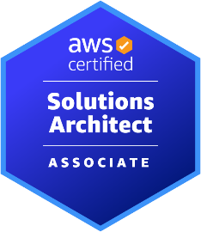
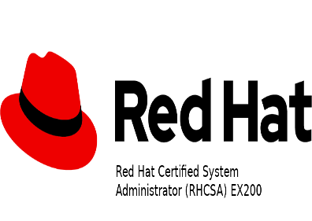

VINAYAK YADAV

Linux/AWS/Devops Engineer

7798440234/8483933736| yadavvinayakk@gmail.com | Pune| https://www.linkedin.com/in/vinayak-aws/

LINUX ADMINISTRATION | AWS | JENKINS | ANSIBLE | DOCKER | KUBERNETES

SUMMARY:
- System administrator with 4.5 years of experience in IT.
- Experience in AWS and DevOps automation tools like Git, Jenkins, Ansible, and container and clustering tool like Docker, Kubernetes, IaC as a Terraform.
- Proficient with configuration management tools and in developing CI/CD pipelines.

WORK EXPERIENCE:
Skylex Technologies Pvt Ltd , Pune (Feb 2019 to July 2023)

PROJECT DETAILS:
Project 1: NetAdmin App
Role: System Administrator (Function: Linux admin)
Description: As a Linux system administrator, Configure, manage, and troubleshoot RHEL based Linux servers.
Automation/configuration management of 4000+ servers using Ansible, and Centos Linux OS.
  - Install, configure, update, and troubleshoot services for production team such as OS-level concerns.
  - Used Ansible as a Configuration management tool to automate repetitive tasks.
  - Written the Ansible YAML scripts to configure the remote servers.
  - Automating regular tasks like backup and scheduling using Shell scripts using bash and run through Cron jobs.
  - Experience on RHEL 7 implementation, administration, installation, and maintenance.
  - Blocking The unwanted IP with help of firewalls / iptables.
  - Configuring PMTA, Apache Http, Maria DB, NFS, DHCP, Syslog, DNS, IP configuration.
  - Setting up DNS record (A, AAAA, NS, MX, CNAME, SPF, DKIM, DMARK)
  - Checking the connectivity and server health of the server with ansible
  - Maintained and developed the ansible YAML files for new deployments.
  - Setup and maintain users, groups in linux.
  - Strong technical background in Storage, Disk management, Logical Volume Management, and logical partitioning.
  - Management of User Accounts, Group user accounts, provide permission to them.
  - Installation of Patches, software’s upgrades using RPM and YUM.
  - Maintaining the inventory of the resources and managing the new orders as per the requirement.
  - Knowledge about Red Hat satellite server.
  - Provided on-call support and worked with Vendors on system issues and bugs for its resolution.
  - Worked on flexible hours for production, backup, and on-call support for a 24/7 environment.
  - Worked on VMware for vm provisioning and decommissioning
  - Worked on windows server 2012 for user management by Active directory

Project 2: Cloud Based E-Commerce App
Role: System Administrator (Function: AWS)
- Amazon Web Services Infrastructure management which includes different AWS services EC2, ELB, EBS, S3, RDS, VPC, Route 53, Auto Scaling, IAM, Security groups, NACL, EFS, CloudWatch.
- Used python boto3 for AWS resource creation and management.
- Create and manage S3 buckets to store and retrieve objects or data.
  - Manage and configure Identity and Access Management (IAM) policies to provide security and access control.
  - Server Monitoring servers via Amazon Cloud Watch & SNS and managing DNS records DNS records on
  - Managing Linux servers on Amazon across EC2, EBS, ELB, SSL, Security Groups, RDS, etc.
  - Creating & managing AMI/Snapshots/Volumes and upgrading/downgrading upgrading/downgrading AWS resources (CPU, Memory, EBS)
  - Creating & realizing EC2 instances on Amazon, Linux, Redhat & Windows to develop POCs in Production Environment.
  - Superintending VPC & subnets, establishing connections between different zones & blocking suspicious IP/Subnet via ACL On a daily basis.
  - Setup and configure EC2 instances, VPC, Public & Private subnets, Route tables, NAT gateway, IGW for secure access, security groups to protect AWS resources
  - Configured the load balancers on AWS (Elastic load balancer) and attached Autoscaling.
  - Monitoring and alerting of production using CloudWatch and SNS.
  - Install docker on Amazon EC2 Instances.
  - Create Dockerfiles and docker images for each service.
  - Hands on experience in Amazon Elastic Kubernetes Service (Amazon EKS) cluster creation and management
  - Designed and implemented an end to end CI/CD pipeline for Java based applications using Jenkins Automation Server.
  - Utilize infrastructure-as-code tools like Terraform to provision and manage cloud resources in automate and repeatable manner
  - Setup and Integrated Nexus repository with CI for storing artifacts.
  - Integrated SonarQube with CI pipeline for code coverage and quality gate results.
  - Responsible for Dev, QA, and stage release builds.
  - Configured the email notification for every build, deployment & approval request.
  - Good expertise in troubleshooting the problems generated while building, deploying and production support.
  - Used Python scripting for automation.
  - Deployed 24+ microservices to the kubernetes cluster including Postgres, Redis, and NGINX ingress controller.

SKILLS:
  - Version Control System: GitHub
  - Programming: Bash scripting
  - CI-CD: Jenkins
  - Containerization Tool: Docker, Kubernetes
  - Operating system: RHEL Linux, CentOS, Windows
  - AWS: EC2, ELB, EBS, S3, RDS, VPC, Route 53, Auto Scaling, IAM
  - Monitoring Tool: Amazon CloudWatch
  - Configuration Management Tool: Ansible.

EDUCATION:
  - University of Mumbai
B.E Information Technology

CERTIFICATION:
  - Red Hat Certified System Administrator (RHCSA), 2017
  - AWS Certified Solutions Architect Associate - SAA C03, Oct2023

